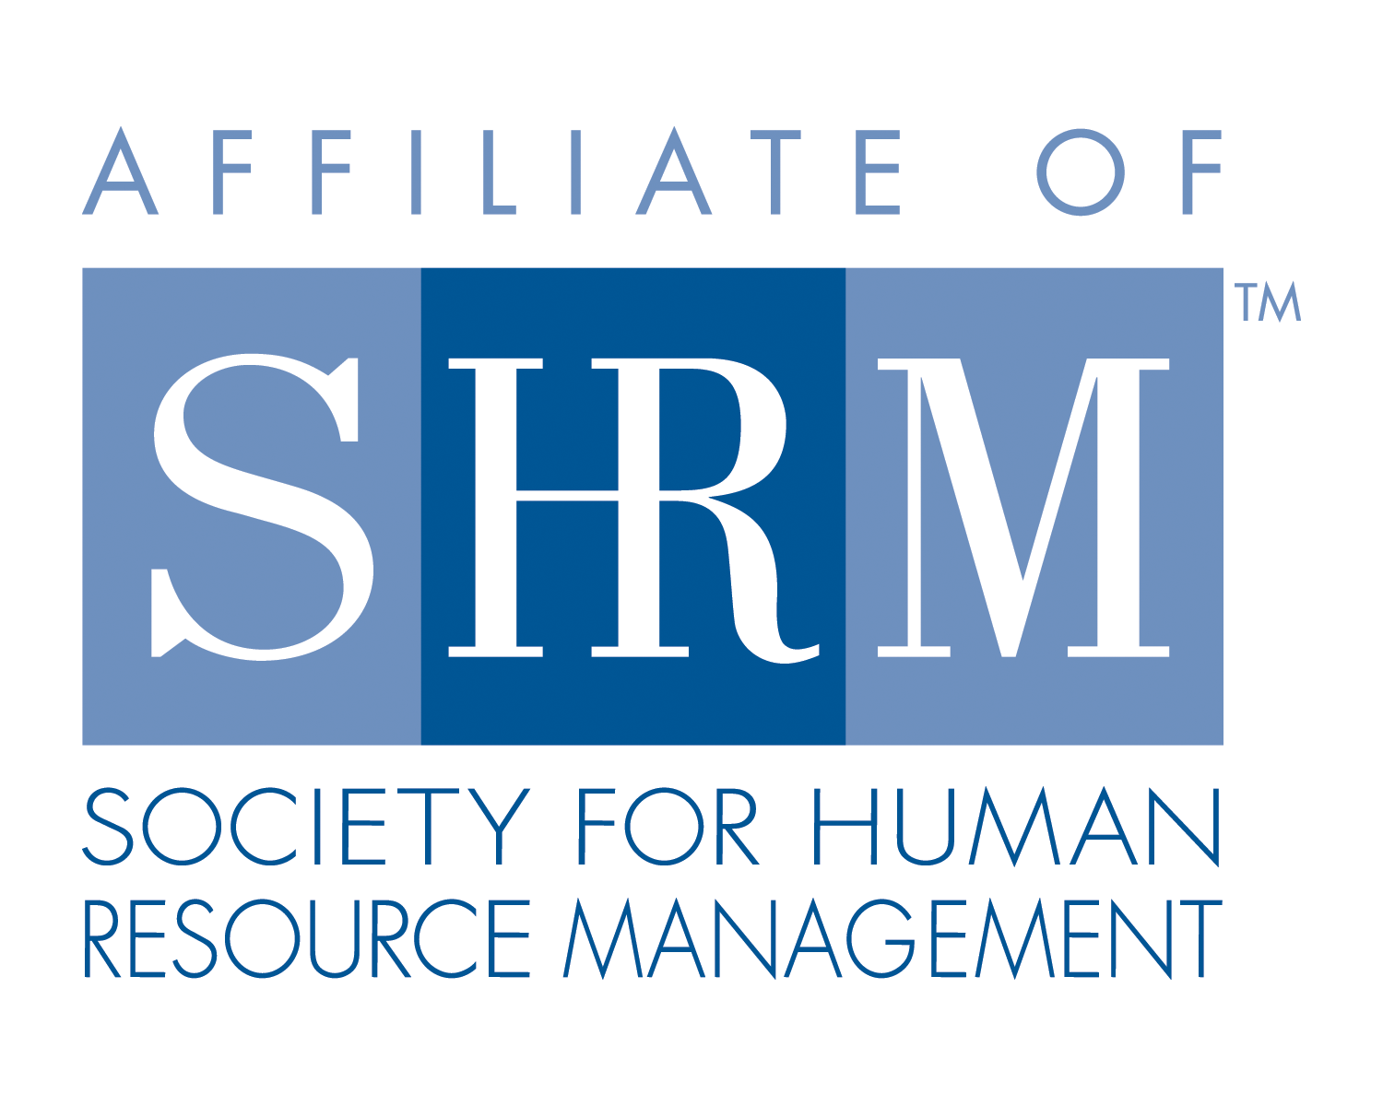


West Georgia SHRM General Meeting
West Georgia Technical College, Troup County Room
June 14, 2012

- Call to Order: Chapter President Pamela Carrne called the monthly meeting of West Georgia SHRM to order at 11:57am on Thursday, June 14th, year at West Georgia Technical College in the Troup County Room.
  - New Members and Visitors were welcomed

- General Meeting Minutes were reviewed and approved

- Announcements:
  - Job Openings/Resumes
  - Upcoming Speakers –
- August: GA DOL Commissioner Mark Butler will be speaking at the August 9th meeting.

- Chair Reports:
  - Treasurer – Treasury report given by Karen Redic.
  - Membership
  - Communications
  - SHRM Foundation
  - College and Education Relations
  - Legislative/Secretary
  - Workforce Development

- Speakers:
  - W. Jonathan Martin, II – Partner – Constangy; New EEOC regulations and how they affect our business.

- Adjournment:
  - No door prize this month.

Adjourned at 1:06pm

